MOUNDVILLE NATIVE AMERICAN FESTIVAL 2020
~ COLORING CONTEST ~
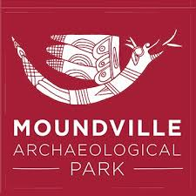
Color the Bird Serpent for your chance to win this year’s Coloring Contest! 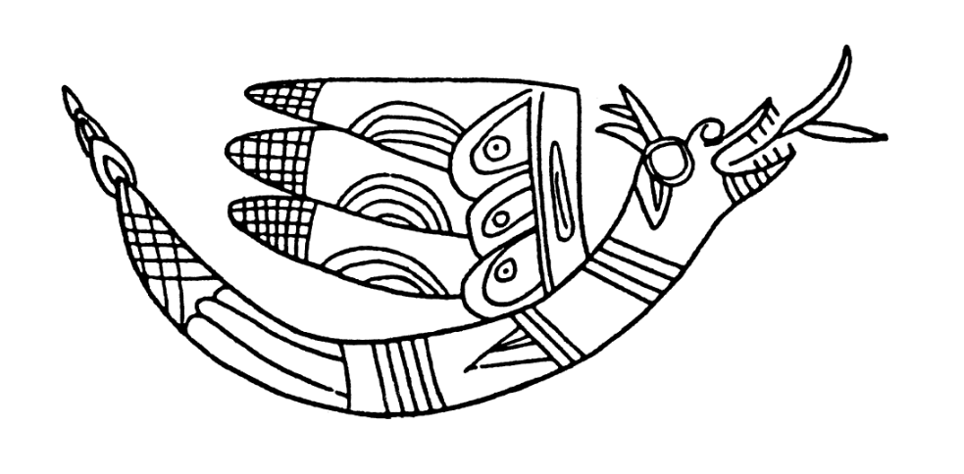
About the Bird- Serpent

The mythic “winged-serpent”, a common symbol at Moundville, combines the body of a venomous rattlesnake and the wings of a bird. Ancient cultures often depicted and sometimes combined exceptional features of creatures found in their local environment in their artwork. Many "winged-serpents" are found on Moundville pottery.

