Class Activities Pre-Visit
- Ask your students what they think when they hear the word “Indian.” Do their responses show any evidence of stereotypes about Native Americans? For example, some students may think that all Native Americans lived in teepees and wore long feathered headdresses, when in reality these were characteristics of the Plains Indians, not Southeastern Native Americans. Discuss how Native Americans are portrayed on television and in movies.

- Discuss the difference between an archaeologist and a pot hunter. An archaeologist uses scientific methods to carefully excavate sites and study all aspects of past human activities. A pothunter is someone who recklessly digs up artifacts to sell. Why would archaeologists not want pothunters to dig up artifacts?

- Plant corn, bean, and/or squash seeds. These were the primary crops for Moundville Indians. Discuss what is needed to grow these types of plants. Point out that without chemical fertilizers, the Indians relied on the winter rains to flood the rivers and bring in fertile soil on their farmland. Ask your students to imagine farming without modern tools. What kind of tools did the Indians need to farm? Explain that Moundville Indians made hoes with wooden handles and a stone blade. Indians in other areas used conch shells or bison shoulder blades for hoe blades.

- The mounds at Moundville were built one basketful of dirt at a time. The shapes of the mounds are truncated pyramids. Set aside an area of your school grounds to experiment with building a miniature mound of your own. Measure the amount of cubic feet of dirt in your mound and how long it took to build. Calculate how long it would take to build a mound the size of Mound B (4 million cubic feet of earth).

- Show students the images below. Get their opinion on what the different designs might mean. Afterwards, let students make their own pottery from self-drying clay (found at most craft stores), decorating their pots with designs from the overhead projection sheet.

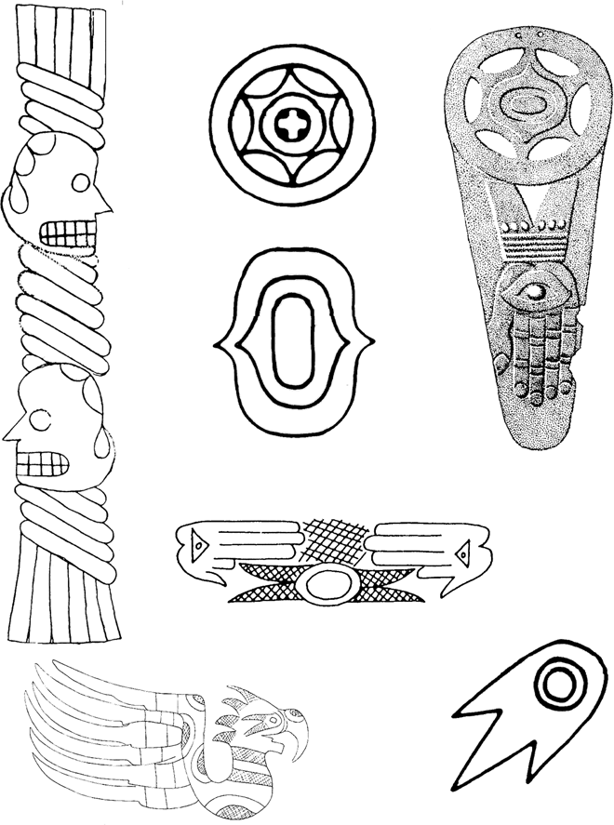
Here are some images found on artifacts made of clay, stone and copper. What do you think they mean?

